EXPERIMENT : 02

NAME : HARISARAN.A ROLL NO : 240701170

Memory Recall Task – Experiment Explanation 🧠

1. Aim
The aim of this experiment is to measure short-term memory and recall ability by testing how many items a participant can remember after briefly viewing them.

2. Objective
To examine how effectively participants can encode, store, and retrieve information from short-term memory after a limited viewing time.

3. Materials
- Computer or laptop
- Memory recall task software/program
- Groups of icons or text items
- Timer (5 seconds viewing time)

4. Procedure
- Participants are seated in front of a computer screen.
- They are informed that groups of icons or text items will appear on the screen.
- Each group will be displayed for 5 seconds only.
- During the viewing time, participants must carefully observe and memorize as many items as possible.
- After the viewing period ends, the screen changes.
- Participants must recall and report the items they remember.
- Accuracy of recalled items is recorded.

5. Instructions to Participants
- Observe the displayed items carefully.
- Try to memorize as many items as possible within 5 seconds.
- After the items disappear, recall them on the next screen.
- Focus on accuracy rather than speed.
6. Variables
- Independent Variable: Number/type of items shown (icons or text).
- Dependent Variable: Number of correctly recalled items.
- Controlled Variables: Viewing time (5 seconds), display format, and testing environment.

7. Expected Outcome
Participants will recall some but not all items, demonstrating the limitations of short-term memory capacity.

8. Conclusion
This experiment helps evaluate memory recall performance and cognitive processing under time constraints. Results can be used to analyze short-term memory capacity and recall accuracy.

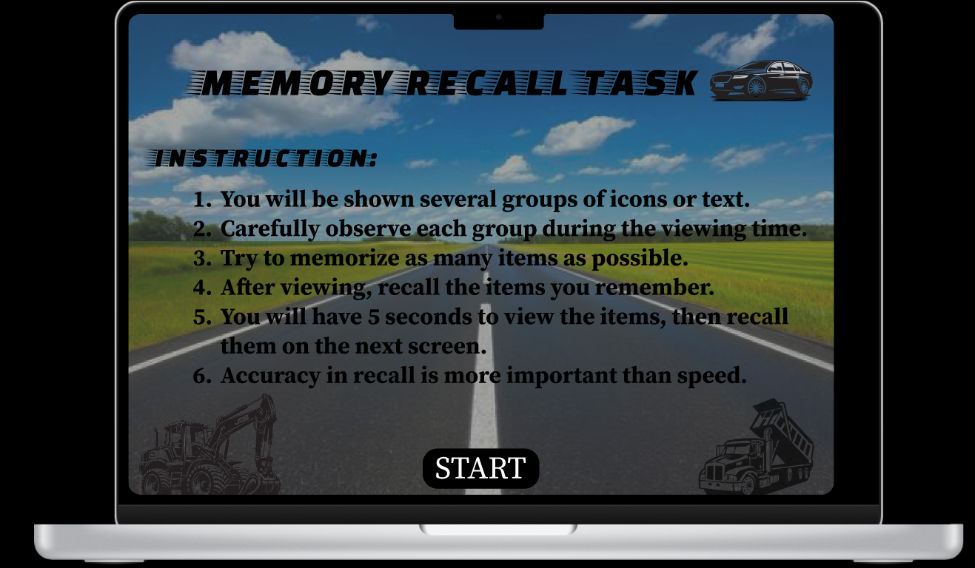

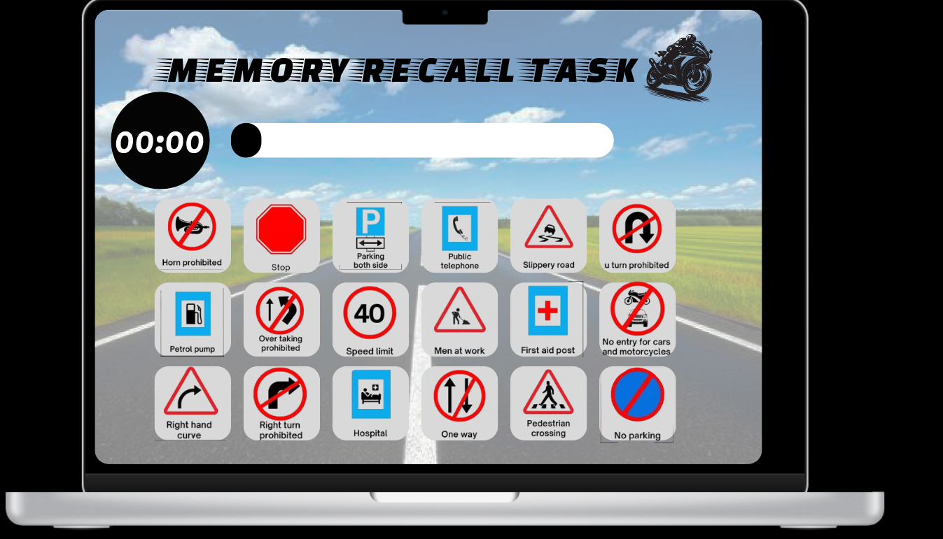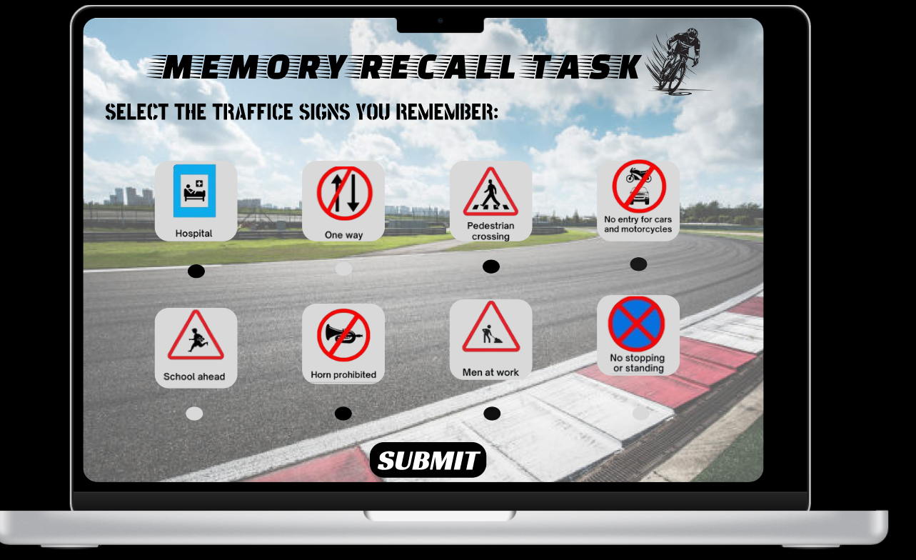

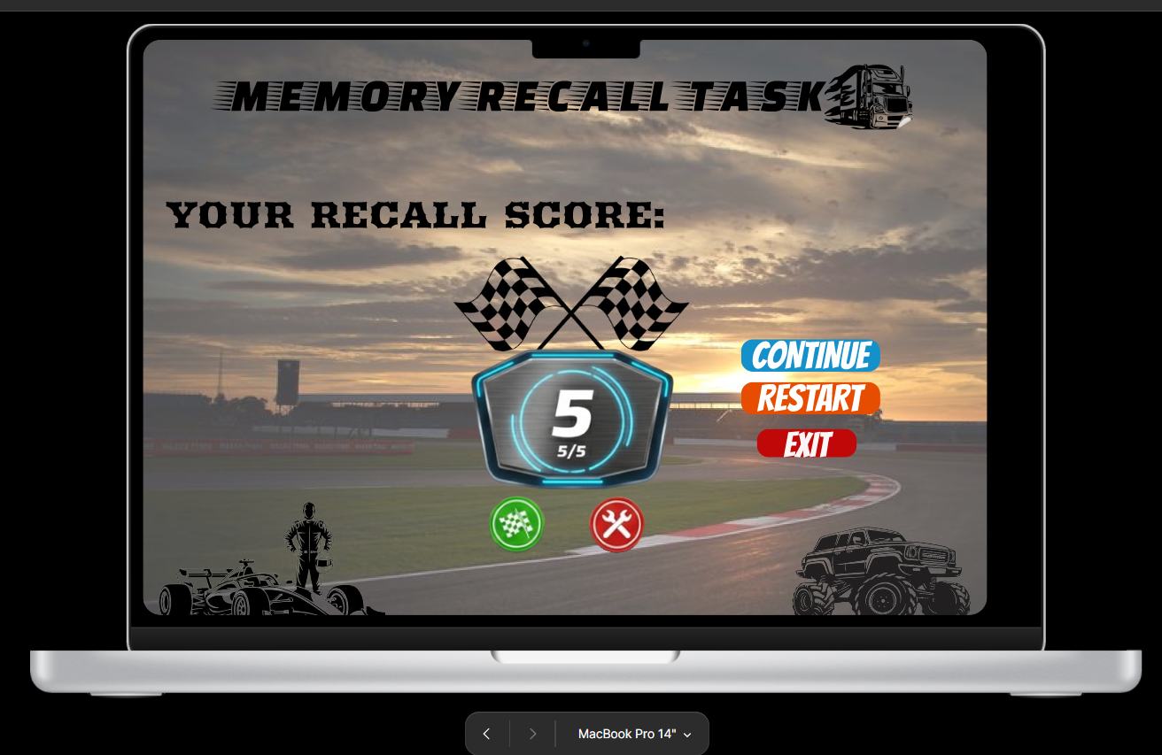

LINK:

https://www.figma.com/proto/uBWZZBzHXciHfsQB1GMXsC/Untitled?node-id=41-29&starting-point-node-id=22%3A2&t=ynCGcSZW3ciPZCgb-1

